**ALL SAINT’S CHURCH SR.SEC. SCHOOL**

**M.I. ROAD , JAIPUR**

**A PROJECT REPORT ON**

**SCHOOL MANAGEMENT SYSTEM**

**SUBJECT: INFORMATICS PRACTICES(065)**

**Session: 2023-2024**

**SUBMITTED BY- SUBMITTED TO-**

**Mohd. Shayyan Mrs. Sharon Amus**

**ACKNOWLEDGMENT**

**I would like to express our special thanks of**

**Gratitude to my teacher Mrs. Sharon Amus for**

**Mentoring me for this project work. I also thank**

**our principal Mrs. Shabnam Haque for her motivation and guidance.**

**My project is titled as School Management System and**

**It enables me to do a lot of research and I came to Know about so many new things.**

**Secondly I would also like to thank our parents and friends who helped us a lot in finalizing this project Within the limited time frame.**

**Mohd. Shayyan**

**XII SCI**

**CONTENT**

1. **Introduction**
2. **System Implementation**
3. **Screenshots**
4. **User Output**
5. **SQL Queries**
6. **User Interface Code**
7. **Testing**
8. **Bibliography**

**INTRODUCTION**

**The “School Management System” undertaken as a project under IP is based on PYTHON AND MYSQL.**

**It’s an attempt to automate the existing system.**

**The project enables its user to perform few**

**operations pertaining to management of School.**

**The Project Enables its user to:**

**1.) Add a new Student, new Staff and new Fee record’s.**

**2.) Delete Student, Staff and Fee record’s.**

**3.) Update Student, Staff and Fee record’s.**

**4.) View Student, Staff and Fee record’s from the Database.**

**System Implementation**

**The hardware used =>**

**--------------------------| System |---------------------------**

**Processor- Intel(R) Core(TM) i5**

**7300U CPU 2.60GHz**

**2.71 GHz**

**Installed memory[RAM]- 8.00 GB(7.88 GB usable)**

**System Type- 64-bit operating system,**

**X64-based processor**

**Pen and Touch- No pen or touch input is**

**Available for this display**

**Screenshots**

**PROJECT TITLE- “SCHOOL MANAGEMENT” DBMS: MySQL Host : localhost User: root Password: root Database: School Table Structure: As per the Screenshot given below:**

**Table: Student**

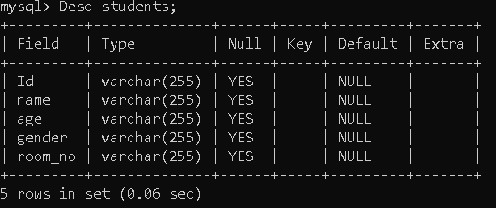

**Table: Staff**

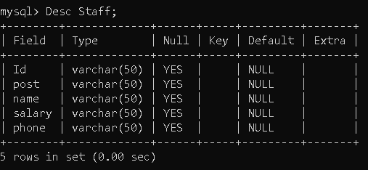

**Table: Fee**

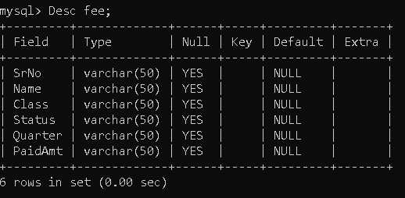

**USER OUTPUT**

**STUDENT DETAILS:**

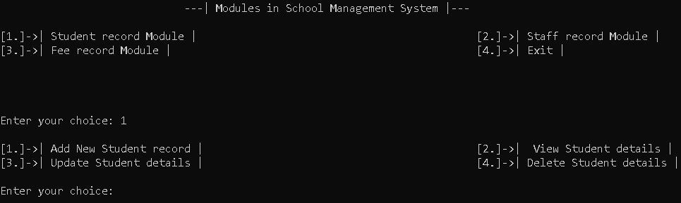

**STAFF DETAILS:**

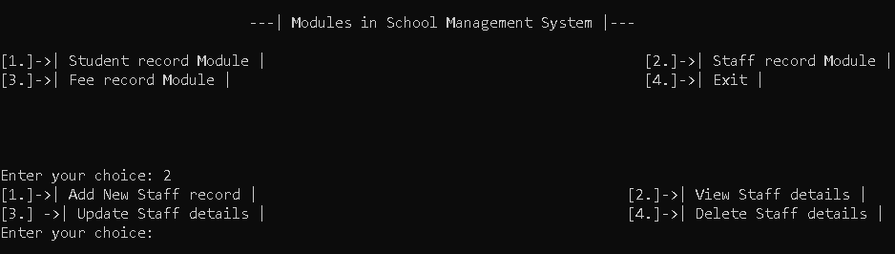

**FEE DETAILS:**

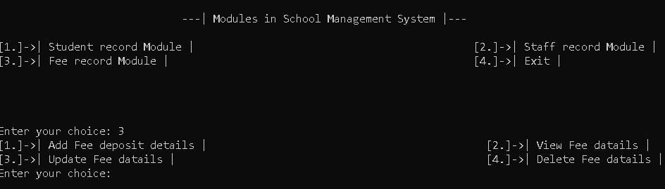

**EXIT DETAILS:**

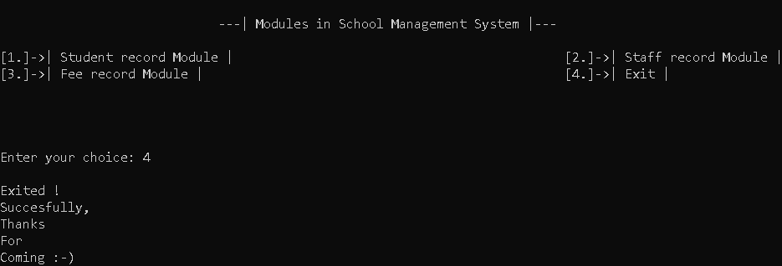

**SQL QUERIES**

**Create database school;**

**use school;**

**CREATE TABLE students (Id VARCHAR(255),name VARCHAR(255), age VARCHAR(255), gender VARCHAR(255), room_no VARCHAR(255));**

**Desc students;**

**use school;**

**create table Staff(Id varchar(50),post varchar(50), name varchar(50),salary varchar(50),phone varchar(50))**

**Desc Staff;**

**use school;**

**create table fee(SrNo varchar(50),Name varchar(50),Class varchar(50),Status varchar(50), Quarter varchar(50),PaidAmt varchar(50));**

**Desc fee;**

**USER INTERFACE CODE**

**print("*" * 130)**

**print(" ---| Welcome to School Management System by Shayyan|---\n")**

**print("*" * 130)**

**# Connecting from the server**

**userName=input("\n ENTER MYSQL SERVER'S USERNAME: ")**

**print("*"*130)**

**password=input(" ENTER MYSQL SERVER'S PASSWORD: ")**

**print("*"*130)**

**print()**

**print(" ---| Modules in School Management System |---")**

**print()**

**print("[1.]->| Student record Module | [2.]->| Staff record Module |")**

**print("[3.]->| Fee record Module | [4.]->| Exit | \n")**

**# Get the user's choice:**

**# if option first:**

**def getchoice():**

**while True:**

**menu()**

**print("\n\n")**

**option = input("Enter your choice: ")**

**if option=='1':**

**print("\n[1.]->| Add New Student record | [2.]->| View Student details |")**

**print("[3.]->| Update Student details | [4.]->| Delete Student details \n")**

**opp = input("Enter your choice: ")**

**if opp=='1':**

**add_student()**

**input("Press ENTER KEY to continue.....")**

**print()**

**elif opp=='2':**

**view_students()**

**input("Press ENTER KEY to continue.....")**

**print()**

**elif opp=='3':**

**update_student()**

**input("Press ENTER KEY to continue.....")**

**print()**

**elif opp=='4':**

**delete_student()**

**input("Press ENTER KEY to continue.....")**

**print()**

**## if option Second:**

**elif option=='2':**

**print("[1.]->| Add New Staff record | [2.]->| View Staff details | ")**

**print("[3.] ->| Update Staff details | [4.]->| Delete Staff details | ")**

**opp =input("Enter your choice: ")**

**if opp=='1':**

**add_staff()**

**input("Press ENTER KEY to continue.....")**

**print()**

**elif opp=='2':**

**view_staff()**

**input("Press ENTER KEY to continue.....")**

**print()**

**elif opp=='3':**

**update_staff()**

**input("Press ENTER KEY to continue.....")**

**print()**

**elif opp=='4':**

**delete_staff()**

**input("Press ENTER KEY to continue.....")**

**print()**

**### if option Third:**

**elif option=='3':**

**print("[1.]->| Add Fee deposit details | [2.]->| View Fee datails | ")**

**print("[3.]->| Update Fee datails | [4.]->| Delete Fee datails | ")**

**opp = input("Enter your choice: ")**

**if opp=='1':**

**fee()**

**input("Press ENTER KEY to continue.....")**

**print()**

**elif opp=='2':**

**view_fee()**

**input("Press ENTER KEY to continue.....")**

**print()**

**elif opp=='3':**

**update_fee()**

**input("Press ENTER KEY to continue.....")**

**print()**

**elif opp=='4':**

**delete_fee()**

**input("Press ENTER KEY to continue.....")**

**print()**

**#### if option Fourth:**

**elif option=='4':**

**print()**

**print("Exited !")**

**print("Succesfully,")**

**print("Thanks")**

**print("For")**

**print("Coming :-)")**

**print()**

**print()**

**print()**

**print()**

**break**

**ADD STUDENT RECORD**

**# Define the function to add a new student**

**def add_student():**

**while True:**

**Id=input("Enter Student SrNo: ")**

**if serbyId(Id)> 0 :**

**print("Duplicate Id, ENTER A VALID ID")**

**else:**

**break**

**name = input("Enter student Name: ")**

**age = input("Enter student DOB: ")**

**gender = input("Enter student gender: ")**

**room_no = input("Enter student Class: ")**

**cursor = mydb.cursor()**

**# CREATING A TABLE**

**cursor.execute('CREATE TABLE students (Id VARCHAR(255),name VARCHAR(255) , VARCHAR(255), gender VARCHAR(255), room_no VARCHAR(255))')**

**# Inserting Values**

**sql = "INSERT INTO students (Id,name, age, gender, room_no) VALUES (%s,%s, %s, %s, %s)"**

**val = (Id,name, age, gender, room_no)**

**cursor.execute(sql, val)**

**mydb.commit()**

**print(cursor.rowcount, "record(s) inserted.")**

**DELETE STUDENT RECORD**

**# Define the function to delete student details**

**def delete_student():**

**Id = input("Enter student SrNo: ")**

**cursor = mydb.cursor()**

**sql = "DELETE FROM students WHERE Id = %s"**

**val = (Id,)**

**cursor.execute(sql, val)**

**mydb.commit()**

**print(cursor.rowcount, "record(s) deleted.")**

**VIEW STUDENT RECORD**

**# Define the function to view student details**

**def view_students():**

**cursor = mydb.cursor()**

**cursor.execute("SELECT * FROM students")**

**result = cursor.fetchall()**

**for row in result:**

**print(row)**

**UPDATE STUDENT RECORD**

**# Define the function to update student details**

**def update_student():**

**id = input("Enter student SrNo: ")**

**name = input("Enter student Name: ")**

**age = input("Enter student DOB: ")**

**gender = input("Enter student gender: ")**

**room_no = input("Enter student Class: ")**

**cursor = mydb.cursor()**

**sql = "UPDATE students SET name = %s, age = %s, gender = %s, room_no = %s WHERE id = %s"**

**val = (name, age, gender, room_no, id)**

**cursor.execute(sql, val) mydb.commit() print(cursor.rowcount, "record(s) updated.")**

**ADD STAFF RECORD**

**# Define the function to add a new staff**

**def add_staff():**

**Id=input("Enter staff ID: ")**

**post=input("Enter staff Post: ")**

**name = input("Enter staff Name: ")**

**salary = input("Enter staff Salary: ")**

**phone = input("Enter staff Phone no: ")**

**cursor = mydb.cursor()**

**# CREATING A TABLE**

**# cursor.execute('create table Staff(Id varchar(50),post varchar(50),name varchar(50),salary varchar(50),phone varchar(50))')**

**# Inserting Values**

**sqls = "INSERT INTO staff (Id,post,name,salary,phone) VALUES (%s,%s,%s, %s, %s)"**

**vals = (Id,post,name,salary,phone)**

**cursor.execute(sqls, vals)**

**mydb.commit()**

**print(cursor.rowcount, "record(s) inserted.")**

**UPDATE STAFF RECORD**

**# Define the function to update staff details**

**def update_staff():**

**Id=input("Enter staff ID: ")**

**post=input("Enter staff Post: ")**

**name = input("Enter staff Name: ")**

**salary = input("Enter staff Salary: ")**

**phone = input("Enter staff Phone no: ")**

**cursor = mydb.cursor()**

**sql = "UPDATE staff SET post= %s, name = %s, salary = %s, phone = %s WHERE Id = %s"**

**val = (Id,post,name,salary, phone)**

**cursor.execute(sql, val)**

**mydb.commit()**

**print(cursor.rowcount, "record(s) updated.")**

**DELETE STAFF RECORD**

**# Define the function to delete staff details**

**def delete_staff():**

**Id = input("Enter staff ID: ")**

**cursor = mydb.cursor()**

**sql = "DELETE FROM staff WHERE Id = %s"**

**val = (Id,)**

**cursor.execute(sql, val)**

**mydb.commit() print(cursor.rowcount, "record(s) deleted.")**

**VIEW STAFF RECORD**

**# Define the function to view student details**

**def view_staff():**

**cursor = mydb.cursor()**

**cursor.execute("SELECT * FROM staff")**

**result = cursor.fetchall()**

**for row in result:**

**print(row)**

**ADD FEE RECORD**

**# Define the function to add Fee details**

**def fee():**

**SrNo=input("Enter Payer SrNo: ")**

**Name = input("Enter Payer Name: ")**

**Class = input("Enter Payer Class: ")**

**Status= input("Enter Status(Paid/Due) : ")**

**Quarter= input("Enter Quarter : ")**

**PaidAmt= input("Enter PaidAmt : ")**

**cursor = mydb.cursor()**

**# CREATING A TABLE**

**cursor.execute('create table fee(SrNo varchar(50),Name varchar(50),Class varchar(50),Status**

**varchar(50),Quarter varchar(50),PaidAmt varchar(50))')**

**# Inserting Values**

**msql = "INSERT INTO fee (SrNo,Name,Class,Status,Quarter,PaidAmt) VALUES (%s,%s, %s, %s,**

**%s,%s)"**

**valu = (SrNo,Name,Class,Status,Quarter,PaidAmt)**

**cursor.execute(msql, valu)**

**mydb.commit()**

**print(cursor.rowcount, "record(s) inserted.")**

**UPDATE FEE RECORD**

**# Define the function to update Fee details**

**def update_fee():**

**SrNo = input("Enter student SrNo: ")**

**Name = input("Enter student Name: ")**

**Class = input("Enter student Class: ")**

**Status = input("Enter student Status(Paid/Due): ")**

**Quarter = input("Enter student Quarter: ")**

**PaidAmt = input("Enter student PaidAmt: ")**

**cursor = mydb.cursor()**

**sqlx = "UPDATE fee SET Name = %s, Class = %s, Status = %s, Quarter = %s,PaidAmt = %s WHERE**

**SrNo = %s**

**valx = (Name,Class,Status,Quarter,PaidAmt,SrNo)**

**cursor.execute(sqlx, valx)**

**mydb.commit()**

**print(cursor.rowcount, "record(s) updated.")**

**VIEW FEE RECORD**

**# Define the function to view Fee details**

**def view_fee():**

**cursor = mydb.cursor()**

**cursor.execute("SELECT * FROM fee")**

**result = cursor.fetchall()**

**for row in result:**

**print(row)**

**DELETE FEE RECORD**

**# Define the function to delete Fee details**

**def delete_fee():**

**SrNo = input("Enter student SrNo: ")**

**cursor = mydb.cursor()**

**sqle = "DELETE FROM fee WHERE SrNo = %s"**

**vale = (SrNo,)**

**cursor.execute(sqle, vale) mydb.commit() print(cursor.rowcount, "record(s) deleted.")**

**TESTING**

**Software testing is an empirical investigation conducted to provide skateholders with information**

**About the quality of the product or service under test, with respect to the context in which it is**

**Intended to operate. Software testing also provides an, independent view of the software to allow**

**The business to appreciate and understand the risk at implementation of the software.**

**Test techniques include, but are not limited to the process of executing a programme or**

**Application with the intent of finding software bugbugs.**

**It can also be stated as the process of validating and verifying that a software programme/**

**Application / product meets the business and technical requirements that guided the**

**its design and development, so that it works a expected and can be implemented with**

**the same characteristics. Software testing, depending on the testing method employed,**

**can be implemented at anytime in the development process however the most test**

**effort is employed after the requirements have been defined and coding process has**

**been completed.**

**BIBLOGRAPHY**

* **Google for Research**
* **www.wikipedia.com**
* **www.geeksforgeeks.org**